Runs on systems running Linux 3.18.7-gentoo x86_64 (Linux 64bit) (Appendix 1) (PHP Info running on Aber server, 2015)[1] [2] [3]

PHP Version 5.6.13 (Appendix 2)

Apache Web server (Appendix 3)

PHPUnit requirements[4]

* PHP 5.6 – although using the latest PHP version is recommended
* Dom and json extensions
* Pcre, reflection and spl extensions – these are enabled and cannot be disabled without intervention
* Xdebug or tokenizer extensions for code coverage reports, and xmlwriter for generating XML reports

Appendices

Appendix 1 – Linux version

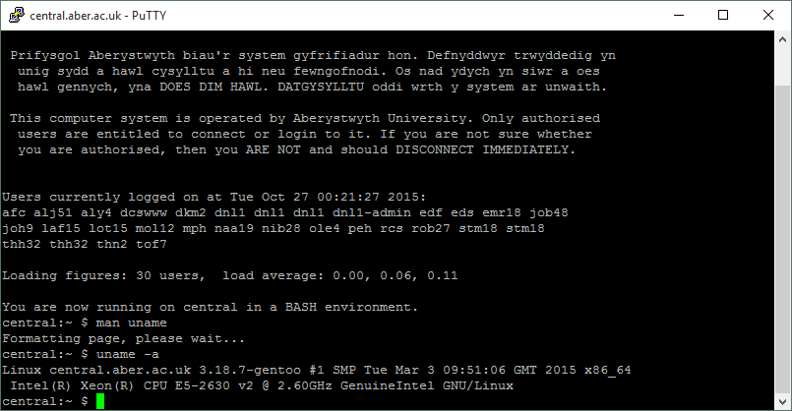

Appendix 2 – PHP version

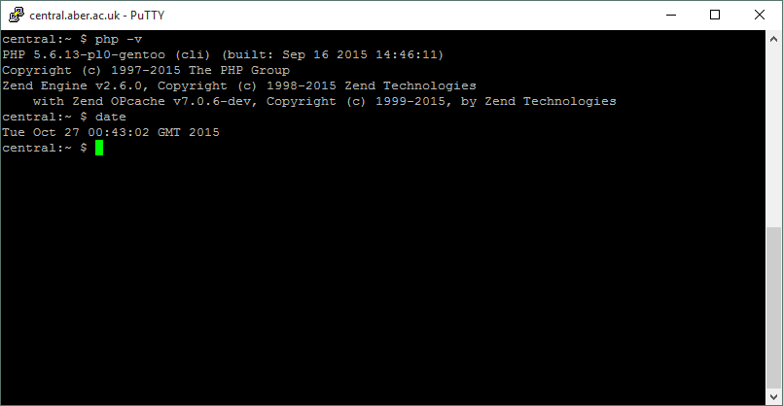

Appendix 3 – Apache version contained in the HTTP GET header of a curl command

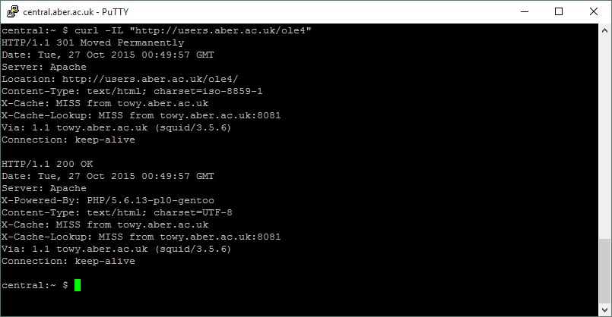

1. PHPInfo (phpinfo.php). (2015, October 27). Retrieved October 27, 2015, from http://users.aber.ac.uk/ole4/phpinfo.php
2. Phpinfo. (2015, October 26). Retrieved October 27, 2015, from http://php.net/manual/en/function.phpinfo.php
3. Users.aber.ac.uk. (n.d.). Retrieved October 27, 2015, from http://users.aber.ac.uk/en/resources/php.php
4. PHPUnit Manual. (2015, October 27). Retrieved October 27, 2015, from https://phpunit.de/manual/current/en/phpunit-book.html#installation.requirements